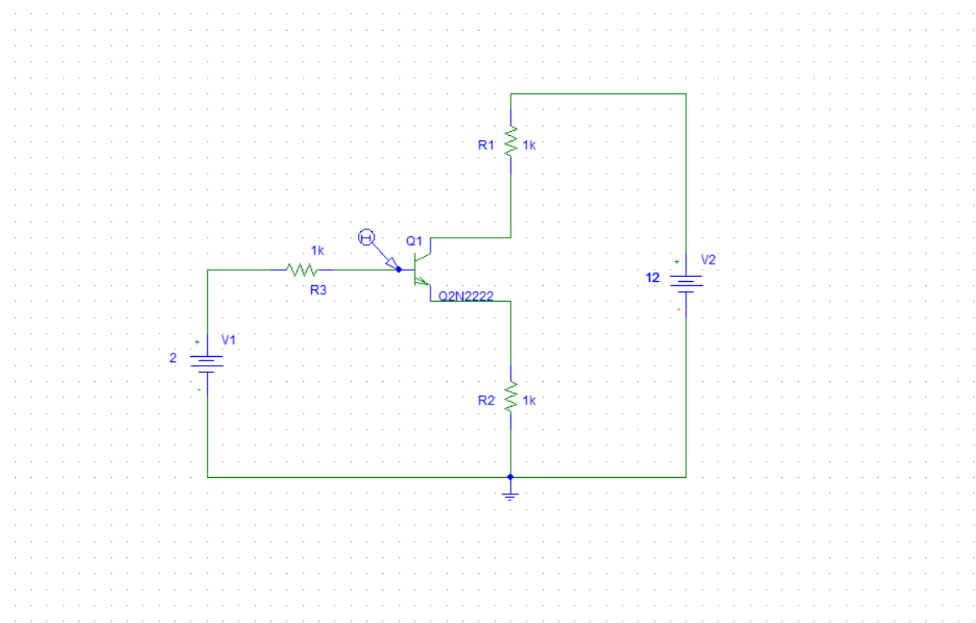

BJT INPUT CHARACTERISTICS CURVE CIRCUIT

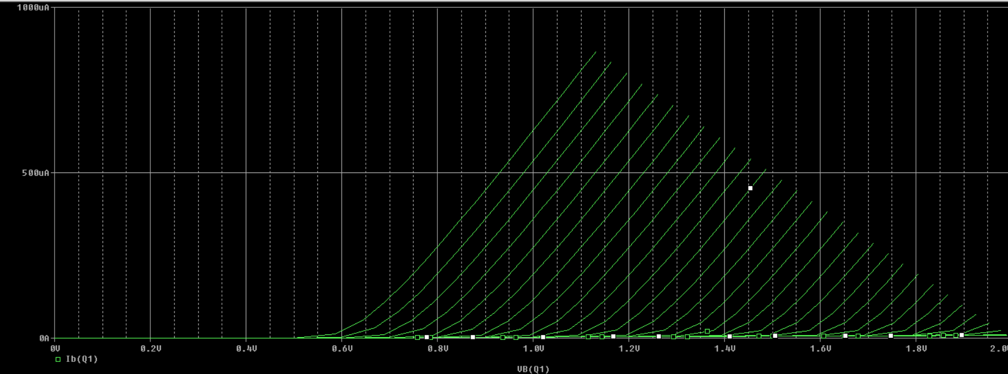

BJT INPUT CHARACTERISTICS WAVEFORM